Final project

**Retail Store Microservices Project**

**Provision Infrastructure**

**Create VPC**

aws ec2 create-vpc \

--cidr-block 10.0.0.0/16 \

--tag-specifications 'ResourceType=vpc,Tags=[{Key=Name,Value=ecommerce-vpc}]'

**Enable DNS Support for VPC (important for EKS & RDS)**

aws ec2 modify-vpc-attribute --vpc-id vpc-0d049e4b3baff6e6d --enable-dns-hostnames "{\"Value\":true}"

aws ec2 modify-vpc-attribute --vpc-id vpc-0d049e4b3baff6e6d --enable-dns-support "{\"Value\":true}"

**Create Two Public Subnets**

**# Public Subnet 1**

aws ec2 create-subnet \

--vpc-id vpc-0d049e4b3baff6e6d \

--cidr-block 10.0.1.0/24 \

--availability-zone us-east-1a \

--tag-specifications 'ResourceType=subnet,Tags=[{Key=Name,Value=public-subnet-1}]'

**# Public Subnet 2**

aws ec2 create-subnet \

--vpc-id vpc-0d049e4b3baff6e6d \

--cidr-block 10.0.2.0/24 \

--availability-zone us-east-1b \

--tag-specifications 'ResourceType=subnet,Tags=[{Key=Name,Value=public-subnet-2}]'

**Create 2 Private Subnets**

**# Private Subnet 1**

aws ec2 create-subnet \

--vpc-id vpc-0d049e4b3baff6e6d \

--cidr-block 10.0.3.0/24 \

--availability-zone us-east-1a \

--tag-specifications 'ResourceType=subnet,Tags=[{Key=Name,Value=private-subnet-1}]'

**# Private Subnet 2**

aws ec2 create-subnet \

--vpc-id vpc-0d049e4b3baff6e6d \

--cidr-block 10.0.4.0/24 \

--availability-zone us-east-1b \

--tag-specifications 'ResourceType=subnet,Tags=[{Key=Name,Value=private-subnet-2}]'

**Create Internet Gateway & Attach to VPC**

aws ec2 create-internet-gateway \

--tag-specifications 'ResourceType=internet-gateway,Tags=[{Key=Name,Value=igw-ecommerce}]'

**# Attach IGW**

aws ec2 attach-internet-gateway \

--internet-gateway-id igw-0753b823b48a03a0d \

--vpc-id vpc-0d049e4b3baff6e6d

Create Elastic IP & NAT Gateway

**# Allocate Elastic IP**

aws ec2 allocate-address --domain vpc

**# Create NAT Gateway in Public Subnet 1**

aws ec2 create-nat-gateway \

--subnet-id subnet-037ef86920fac33ac \

--allocation-id eipalloc-0c42307f8e3160fe0 \

--tag-specifications 'ResourceType=natgateway,Tags=[{Key=Name,Value=natgw-ecommerce}]'

**Create Route Tables**

# Create

aws ec2 create-route-table \

--vpc-id vpc-0d049e4b3baff6e6d \

--tag-specifications 'ResourceType=route-table,Tags=[{Key=Name,Value=public-rt}]'

**# Associate with Public Subnets**

aws ec2 associate-route-table \

--subnet-id subnet-037ef86920fac33ac \

--route-table-id rtb-0a9b986f6fe490f9a

aws ec2 associate-route-table \

--subnet-id subnet-0e019d8565854a4bd \

--route-table-id rtb-0a9b986f6fe490f9a

**# Add Route to Internet**

aws ec2 create-route \

--route-table- rtb-0a9b986f6fe490f9a \

--destination-cidr-block 0.0.0.0/0 \

--gateway-id igw-0753b823b48a03a0d

**Private Route Table**

# Create

aws ec2 create-route-table \

--vpc-id vpc-0d049e4b3baff6e6d \

--tag-specifications 'ResourceType=route-table,Tags=[{Key=Name,Value=private-rt}]'

**# Associate with Private Subnets**

aws ec2 associate-route-table \

--subnet-id subnet-0a663a5578e577826 \

--route-table-id rtb-03b5b20b2c002534b

aws ec2 associate-route-table \

--subnet-id subnet-00ffb4eb2a305529f \

--route-table-id rtb-03b5b20b2c002534b

**# Add NAT Gateway route**

aws ec2 create-route \

--route-table-id rtb-03b5b20b2c002534b \

--destination-cidr-block 0.0.0.0/0 \

--nat-gateway-id nat-0983afca2c7aa72b6

**Create EKS Cluster Using Custom VPC + Subnets**

apiVersion: eksctl.io/v1alpha5

kind: ClusterConfig

metadata:

name: ecommerce-cluster

region: us-east-1

vpc:

id: "vpc-0d049e4b3baff6e6d"

subnets:

private:

us-east-1a:

id: "subnet-0a663a5578e577826"

us-east-1b:

id: "subnet-00ffb4eb2a305529f"

public:

us-east-1a:

id: "subnet-037ef86920fac33ac"

us-east-1b:

id: "subnet-0e019d8565854a4bd"

nodeGroups:

- name: ecommerce-nodes

instanceType: t3.medium

desiredCapacity: 2

minSize: 1

maxSize: 3

privateNetworking: true

**eksctl create cluster -f eks-cluster-config.yaml**

**Setup kubectl Access**

aws eks update-kubeconfig --region us-east-1 --name ecommerce-cluster

kubectl get nodes

**Create a DB Subnet Group (for your private subnets)**

aws rds create-db-subnet-group \

--db-subnet-group-name ecommerce-db-subnet-group \

--db-subnet-group-description "DB subnet group for ecommerce app" \

--subnet-ids subnet-0a663a5578e577826 subnet-00ffb4eb2a305529f \

--tags Key=Name,Value=ecommerce-db-subnet-group

**Create RDS (MySQL) for catalog Service**

aws rds create-db-instance \

--db-instance-identifier catalog-db \

--db-instance-class db.t3.micro \

--engine mysql \

--master-username admin \

--master-user-password admin1234 \

--allocated-storage 20 \

--vpc-security-group-ids sg-066f78eea3826325d \

--db-subnet-group-name ecommerce-db-subnet-group \

--no-publicly-accessible \

--backup-retention-period 1 \

--db-name catalogdb

To Get RDS endpoints

aws rds describe-db-instances \

--db-instance-identifier catalog-db \

--query "DBInstances[0].Endpoint.Address" \

--output text

**Create DynamoDB Table for cart Service**

aws dynamodb create-table \

--table-name cart \

--attribute-definitions AttributeName=id,AttributeType=S \

--key-schema AttributeName=id,KeyType=HASH \

--provisioned-throughput ReadCapacityUnits=5,WriteCapacityUnits=5 \

--region us-east-1

**Verify Table Was Created**

aws dynamodb describe-table --table-name cart --region us-east-1

Now start the process of ecr and eks  
git clone https://github.com/aws-containers/retail-store-sample-app.git

cd retail-store-sample-app

Now create Two ECRs with catalog,cart

Go to

src/catalog/Dockerfile

src/cart/Dockerfile

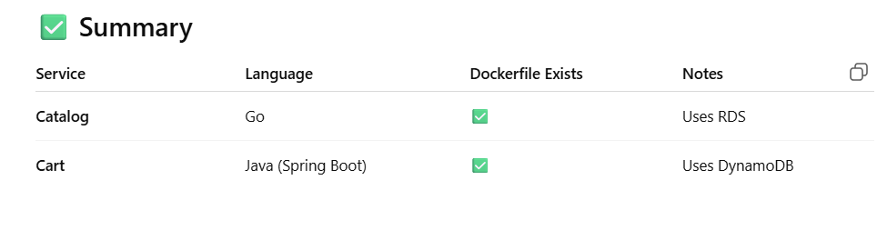

Login for pushing image  
aws ecr get-login-password --region us-east-1 | docker login --username AWS --password-stdin 423623849965.dkr.ecr.us-east-1.amazonaws.com

docker login -u bhargavakulla

Now go to src/catalog  
then perform these commands

docker build -t 423623849965.dkr.ecr.us-east-1.amazonaws.com/catalog .

docker push 423623849965.dkr.ecr.us-east-1.amazonaws.com/catalog

Now go to /src/cart

docker build -t 423623849965.dkr.ecr.us-east-1.amazonaws.com/cart .

docker push 423623849965.dkr.ecr.us-east-1.amazonaws.com/cart

Now come back to retail-store-sample-app  
then create k8s then cd k8s  
  
in k8s folder create  
**catalog-deployment.yaml**

apiVersion: apps/v1

kind: Deployment

metadata:

name: catalog

spec:

replicas: 2

selector:

matchLabels:

app: catalog

template:

metadata:

labels:

app: catalog

spec:

containers:

- name: catalog

image: 423623849965.dkr.ecr.us-east-1.amazonaws.com/catalog:latest

ports:

- containerPort: 8080

env:

- name: DB_HOST

value: catalog-db.cb6eiuesce5w.us-east-1.rds.amazonaws.com

- name: DB_PORT

value: "3306"

- name: DB_USER

value: admin

- name: DB_PASSWORD

value: admin1234

- name: DB_NAME

value: catalogdb

---

apiVersion: v1

kind: Service

metadata:

name: catalog-svc

spec:

selector:

app: catalog

ports:

- port: 80 # exposed port

targetPort: 8080

type: LoadBalancer

**cart-deployment.yaml**

apiVersion: apps/v1

kind: Deployment

metadata:

name: cart

spec:

replicas: 2

selector:

matchLabels:

app: cart

template:

metadata:

labels:

app: cart

spec:

containers:

- name: cart

image: 423623849965.dkr.ecr.us-east-1.amazonaws.com/cart:latest

ports:

- containerPort: 8080

env:

- name: AWS_REGION

value: us-east-1

- name: DYNAMODB_TABLE

value: cart

---

apiVersion: v1

kind: Service

metadata:

name: cart-svc

spec:

selector:

app: cart

ports:

- port: 80 # exposed port

targetPort: 8080

type: LoadBalancer

**ui-deployment.yaml**

apiVersion: apps/v1

kind: Deployment

metadata:

name: store-ui

spec:

replicas: 1

selector:

matchLabels:

app: store-ui

template:

metadata:

labels:

app: store-ui

spec:

containers:

- name: store-ui

image: public.ecr.aws/aws-containers/retail-store-sample-ui:1.0.0

ports:

- containerPort: 8080

**ui-service.yaml**

apiVersion: v1

kind: Service

metadata:

name: store-ui-svc

spec:

type: LoadBalancer

selector:

app: store-ui

ports:

- port: 80

targetPort: 8080

**Then execute these commands**  
kubectl apply -f catalog-deployment.yaml

kubectl apply -f cart-deployment.yaml

kubectl apply -f ui-deployment.yaml

kubectl apply -f ui-service.yaml

kubectl get pods

kubectl get svc

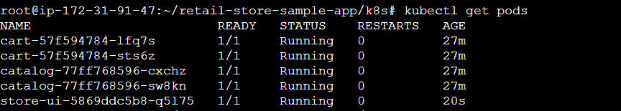





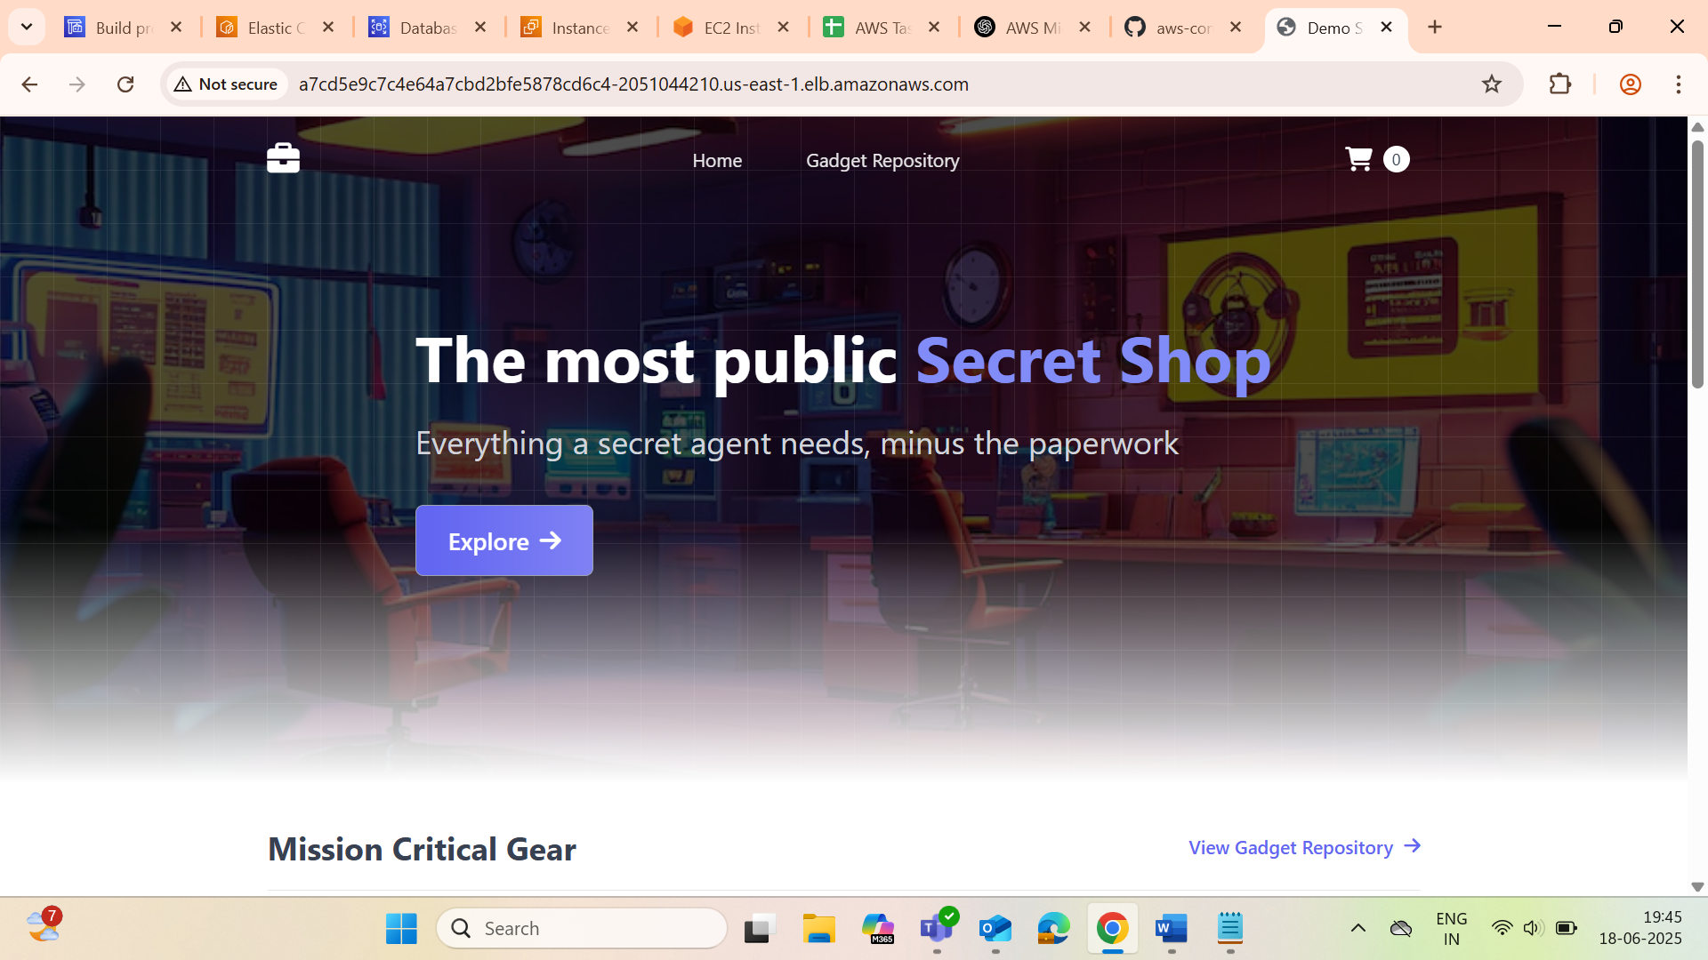

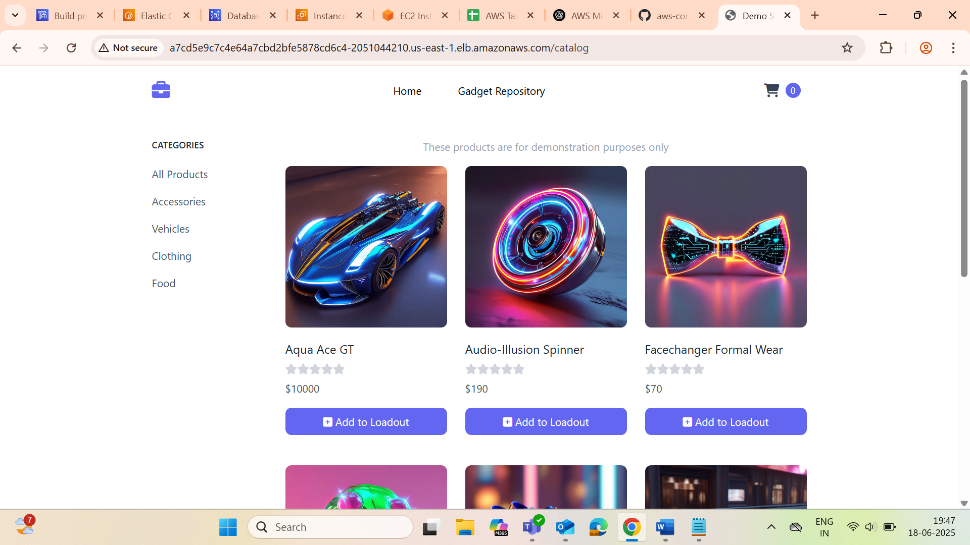

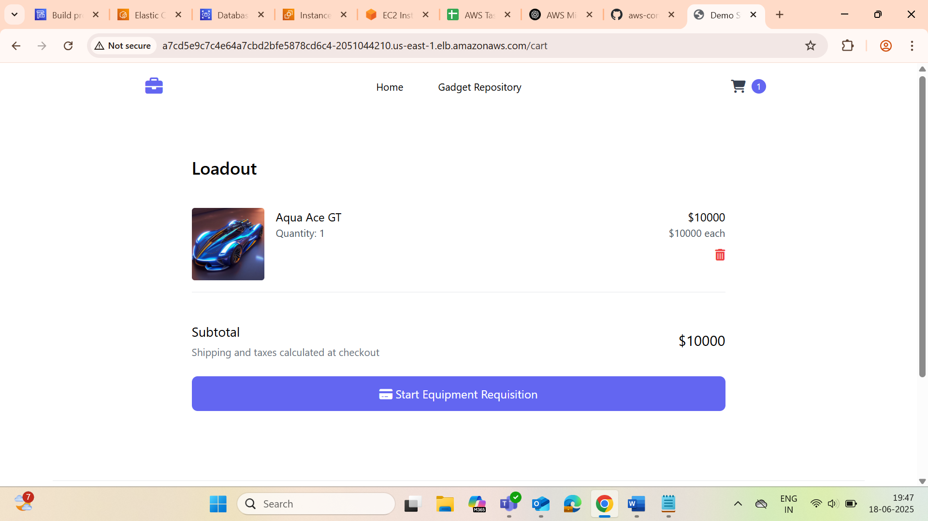

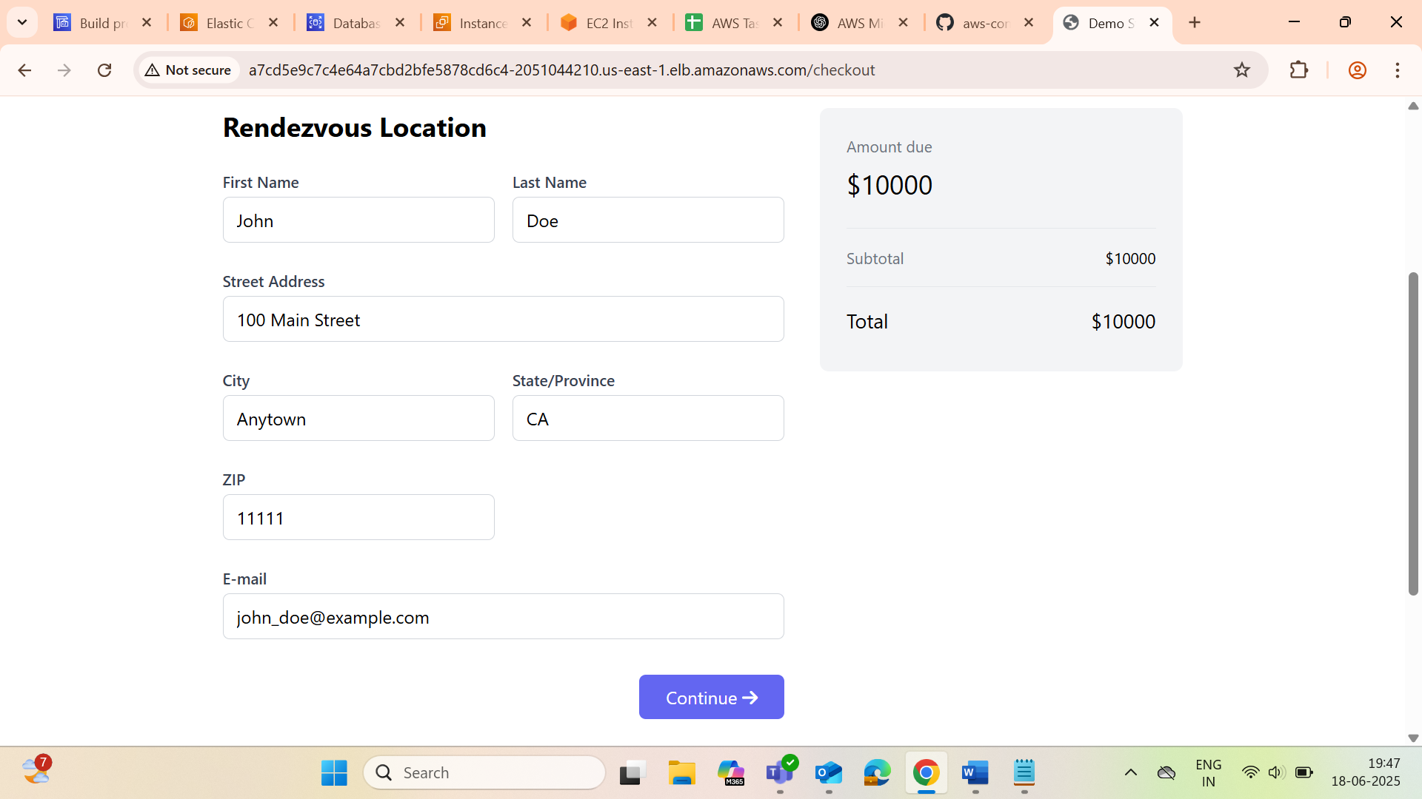

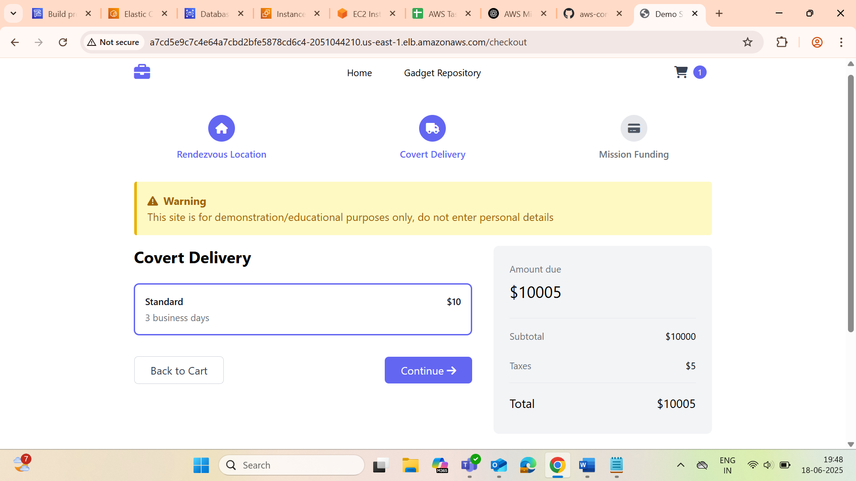

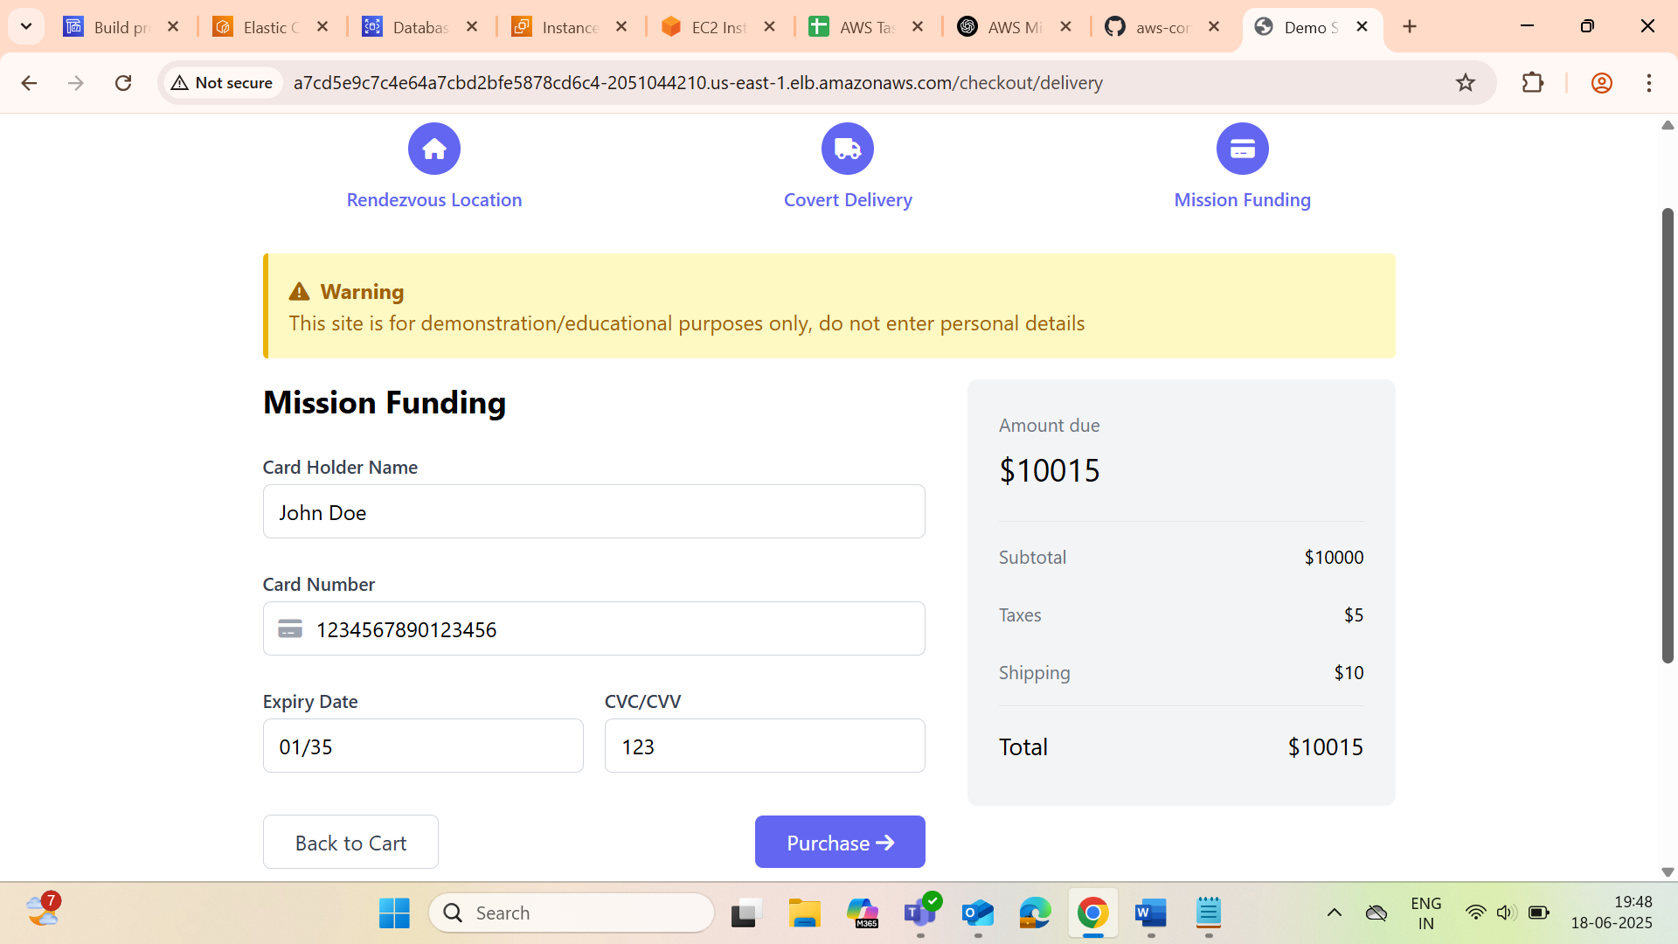

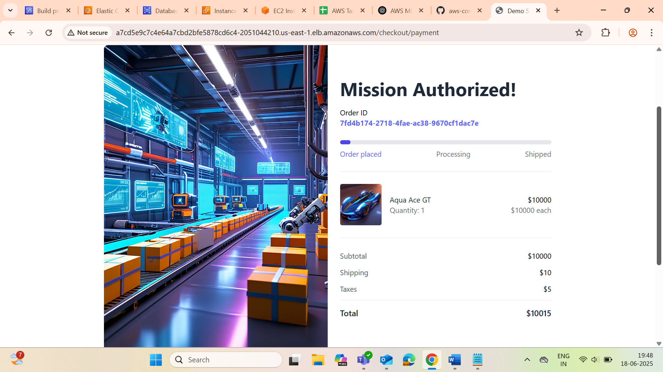

next to do through pipeline   
use buildspec.yaml  
version: 0.2

phases:

install:

commands:

- echo Installing dependencies...

- export AWS_SDK_LOAD_CONFIG=1

pre_build:

commands:

- echo Logging in to Amazon ECR...

- ACCOUNT_ID=423623849965

- REGION=us-east-1

- IMAGE_TAG=v1.$CODEBUILD_BUILD_NUMBER

- aws ecr get-login-password --region $REGION | docker login --username AWS --password-stdin ${ACCOUNT_ID}.dkr.ecr.${REGION}.amazonaws.com

build:

commands:

- echo Building cart image...

- cd src/cart

- docker build -t cart:${IMAGE_TAG} .

- docker tag cart:${IMAGE_TAG} ${ACCOUNT_ID}.dkr.ecr.${REGION}.amazonaws.com/cart:${IMAGE_TAG}

- cd -

- echo Building catalog image...

- cd src/catalog

- docker build -t catalog:${IMAGE_TAG} .

- docker tag catalog:${IMAGE_TAG} ${ACCOUNT_ID}.dkr.ecr.${REGION}.amazonaws.com/catalog:${IMAGE_TAG}

- cd -

post_build:

commands:

- echo Pushing cart image...

- docker push ${ACCOUNT_ID}.dkr.ecr.${REGION}.amazonaws.com/cart:${IMAGE_TAG}

- echo Pushing catalog image...

- docker push ${ACCOUNT_ID}.dkr.ecr.${REGION}.amazonaws.com/catalog:${IMAGE_TAG}

- echo Preparing Kubernetes deployment files...

- mkdir -p k8s-out

- sed "s|IMAGE_PLACEHOLDER|${ACCOUNT_ID}.dkr.ecr.${REGION}.amazonaws.com/cart:${IMAGE_TAG}|g" k8s/cart-deployment.yaml > k8s-out/cart-deployment.yaml

- cp k8s/cart-service.yaml k8s-out/ || echo "No cart-service.yaml found"

- sed "s|IMAGE_PLACEHOLDER|${ACCOUNT_ID}.dkr.ecr.${REGION}.amazonaws.com/catalog:${IMAGE_TAG}|g" k8s/catalog-deployment.yaml > k8s-out/catalog-deployment.yaml

- cp k8s/catalog-service.yaml k8s-out/ || echo "No catalog-service.yaml found"

- cp k8s/ui-deployment.yaml k8s-out/

- cp k8s/ui-service.yaml k8s-out/

artifacts:

base-directory: k8s-out

files:

- cart-deployment.yaml

- catalog-deployment.yaml

- ui-deployment.yaml

- ui-service.yaml

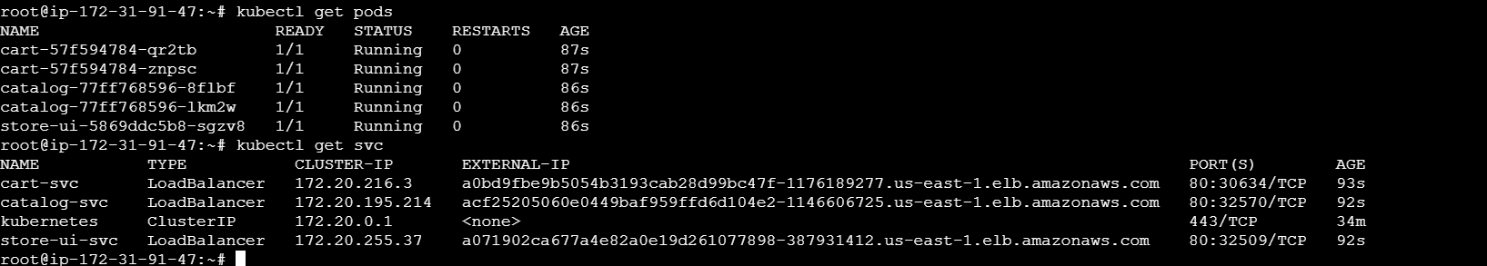

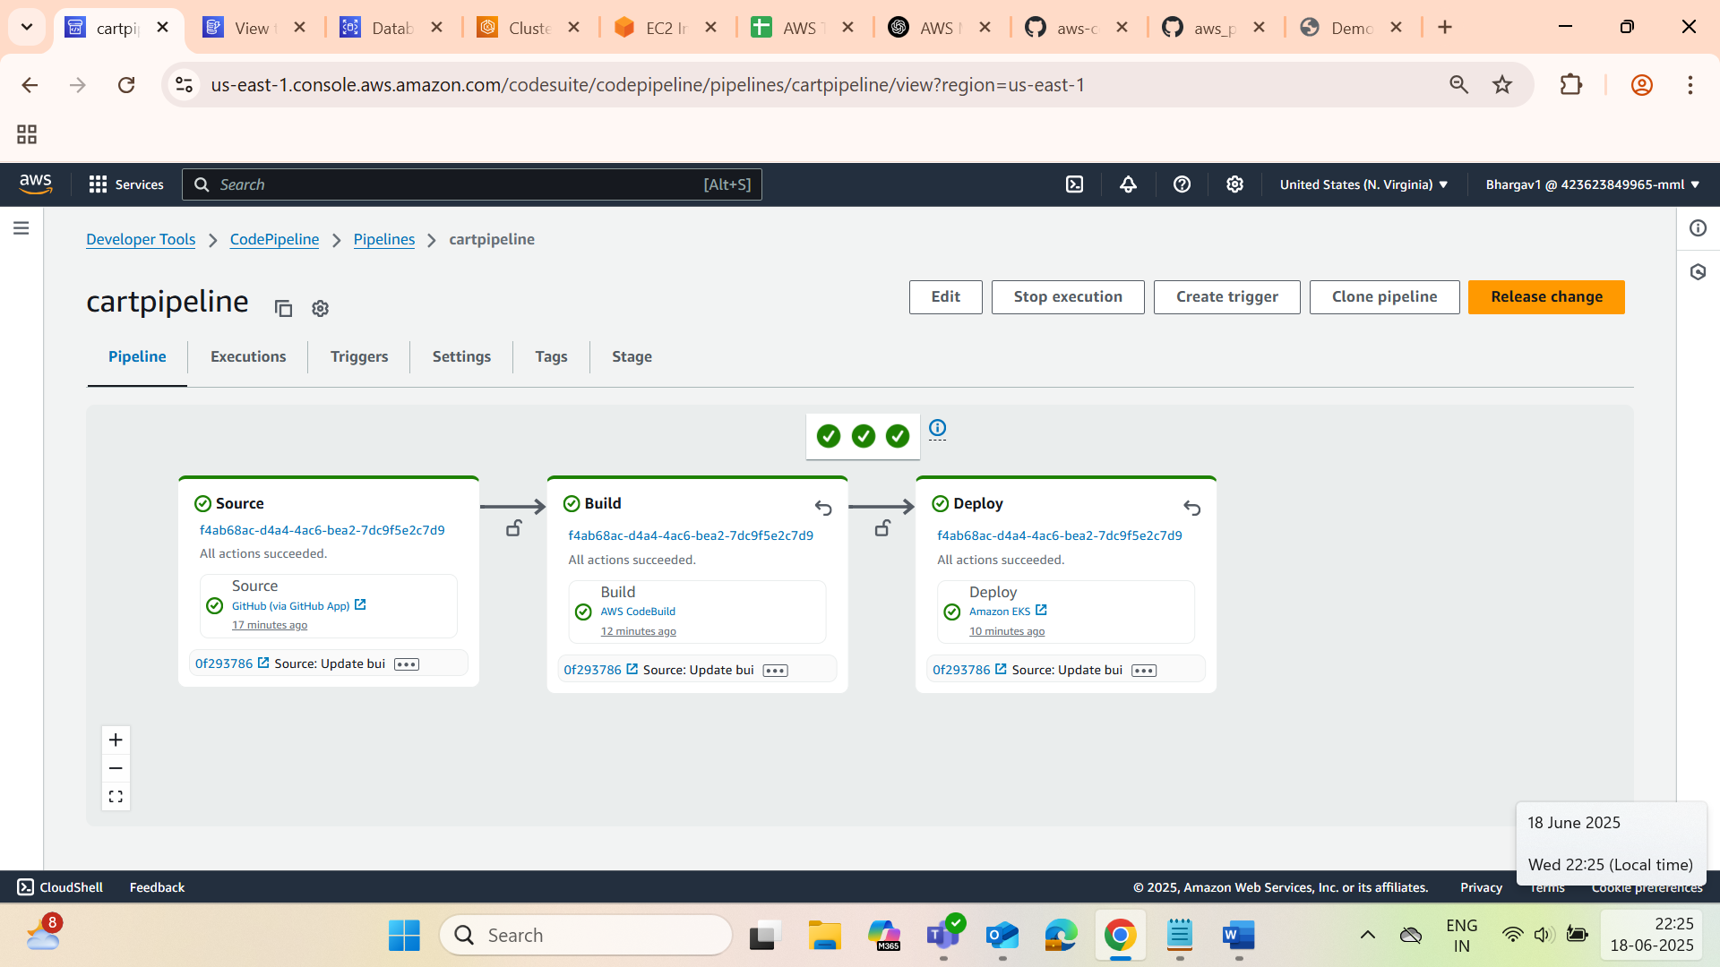

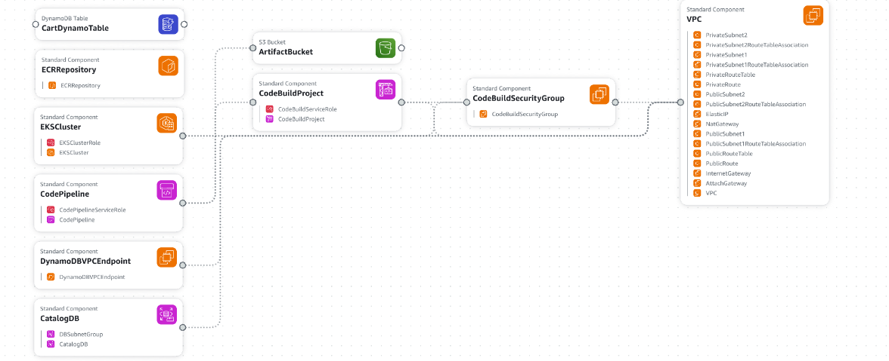

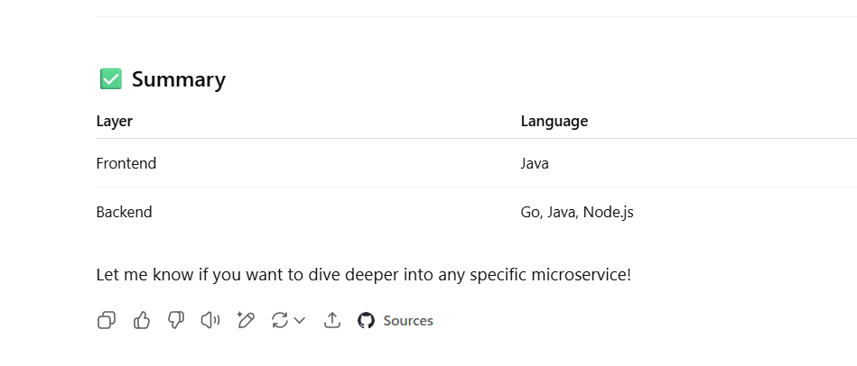

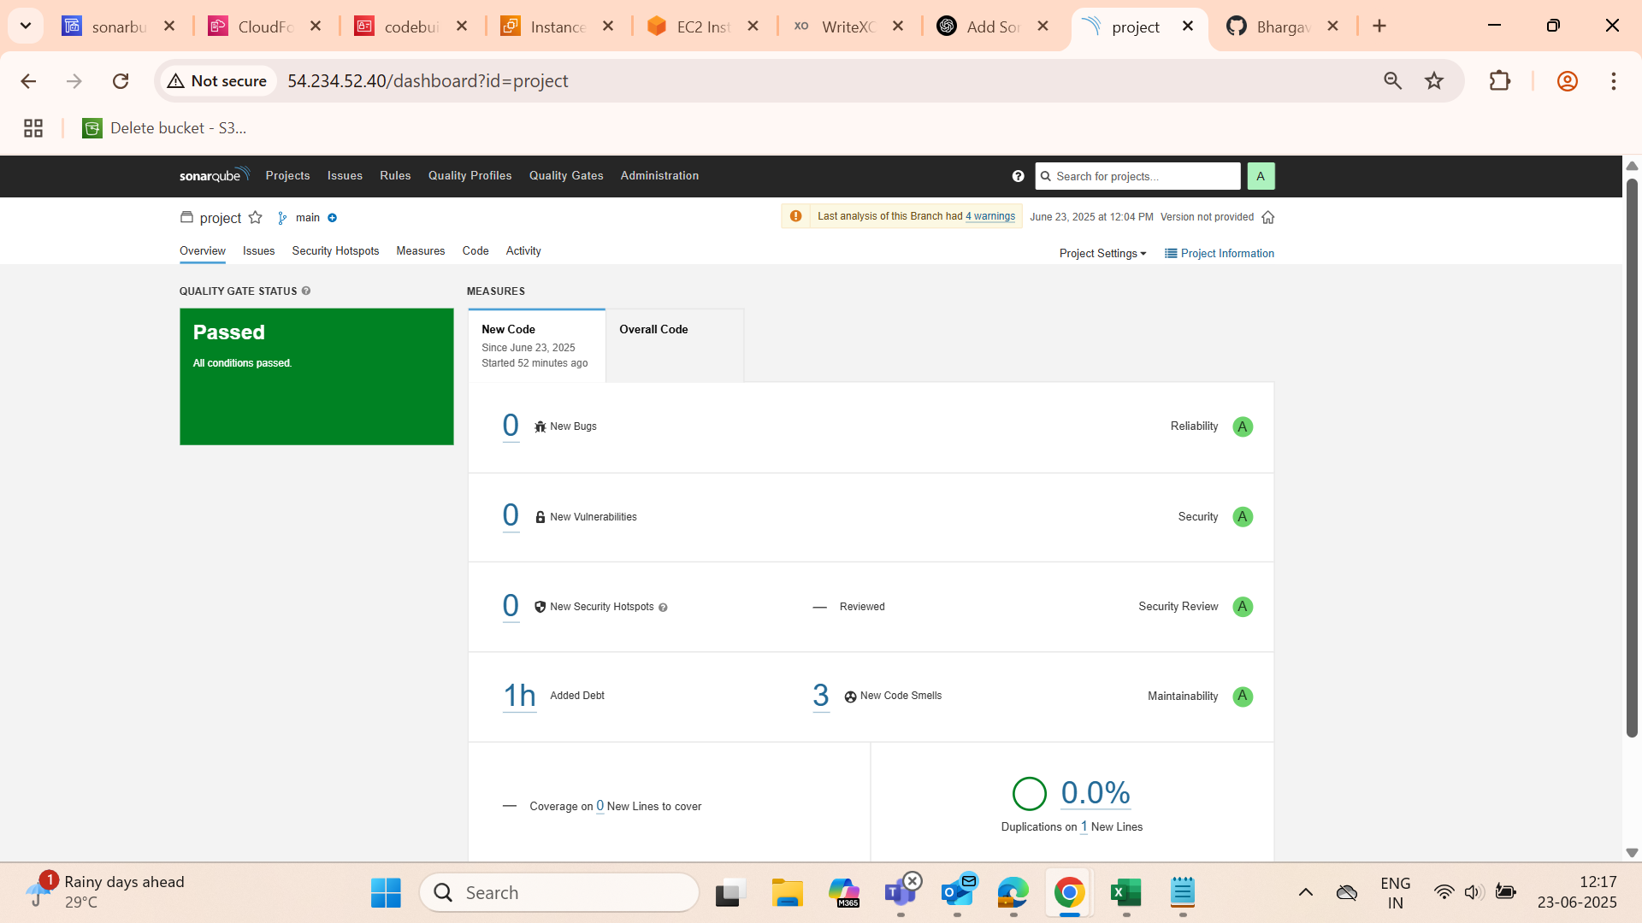

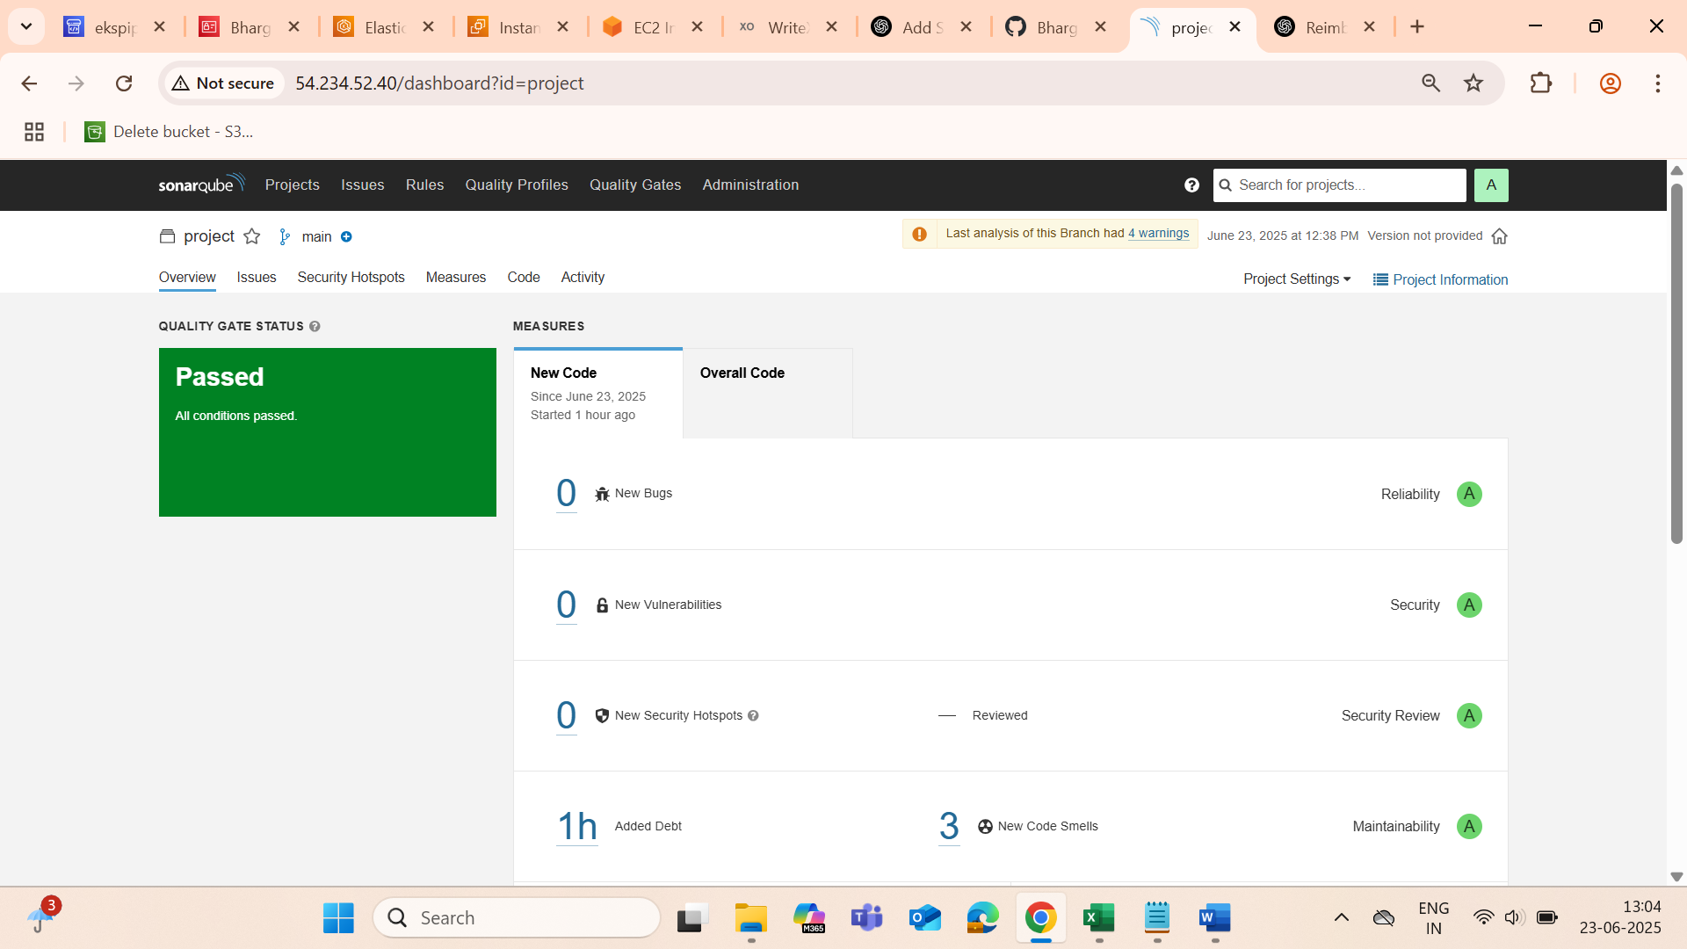

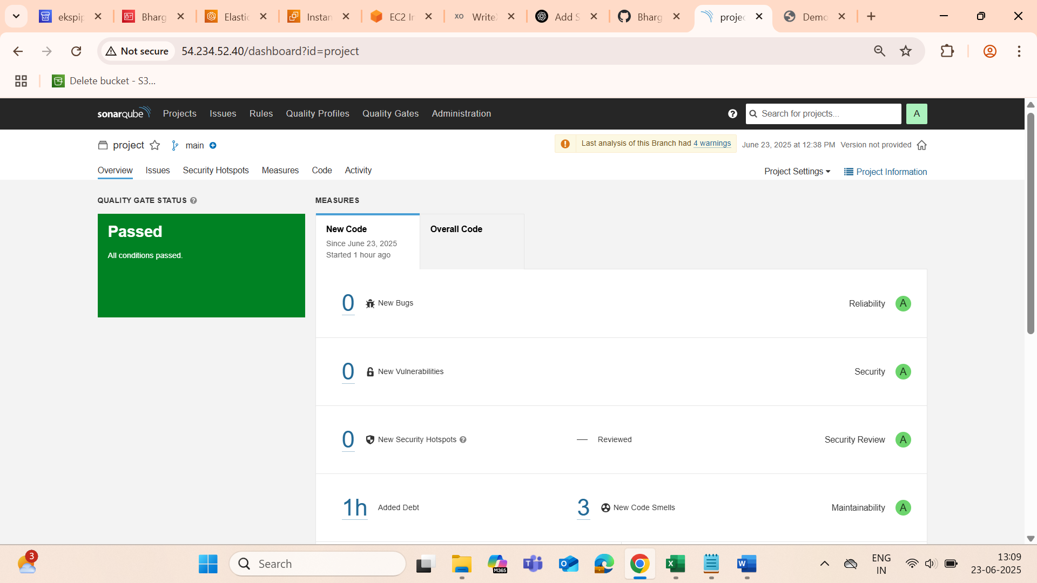

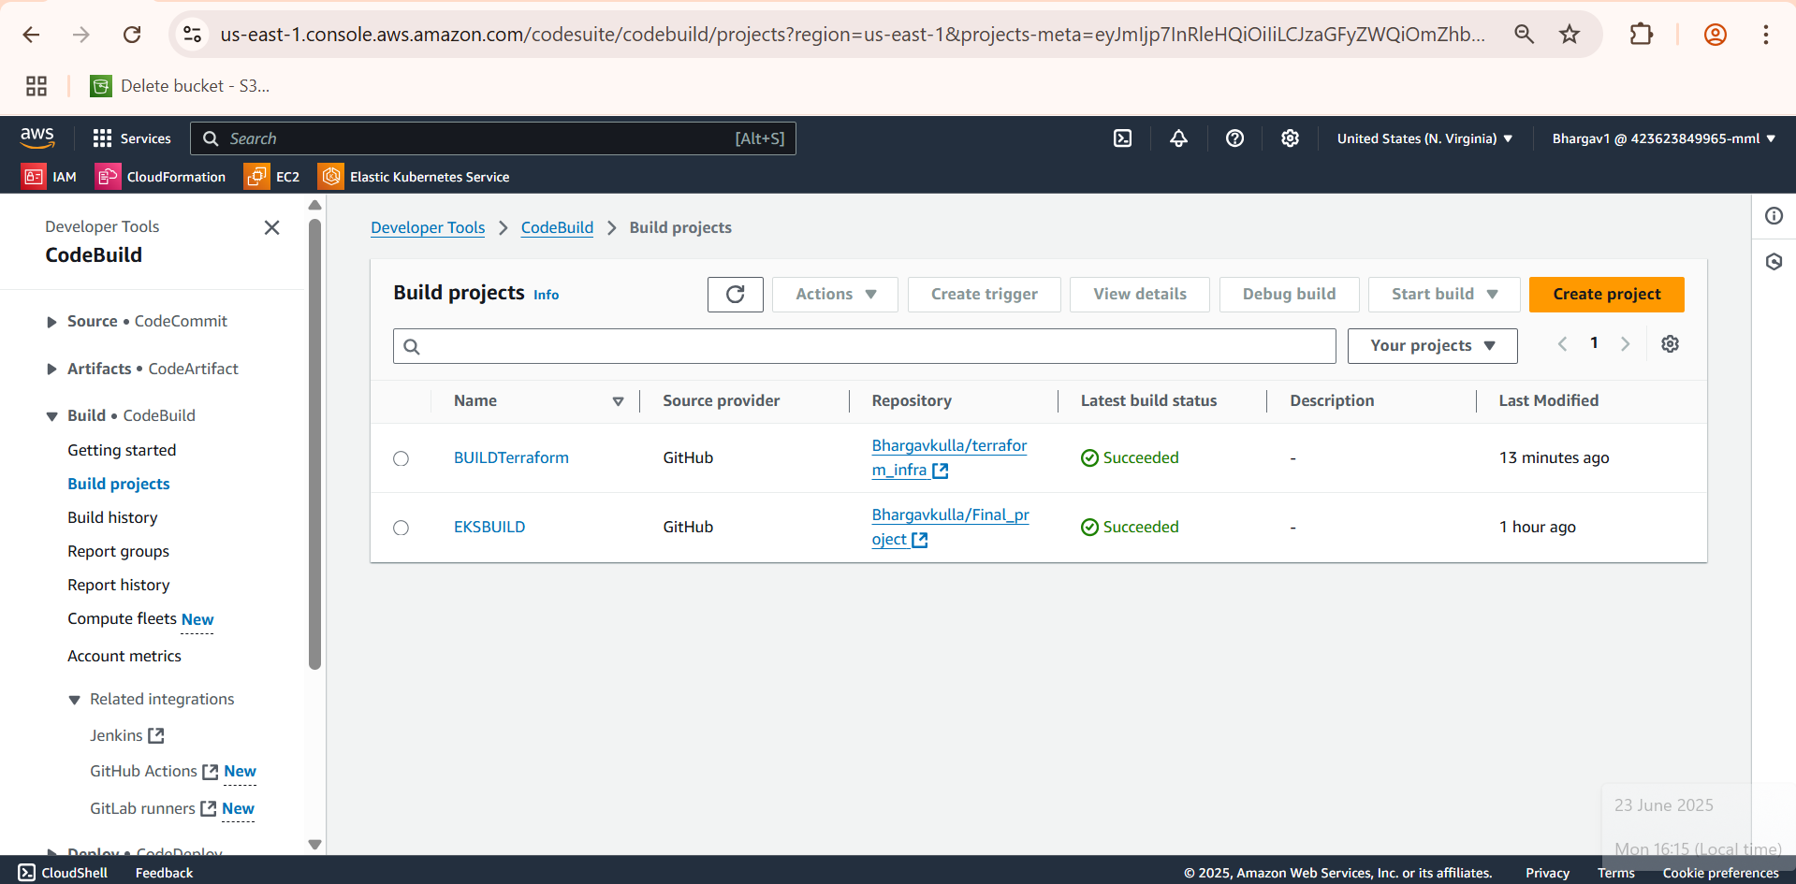  
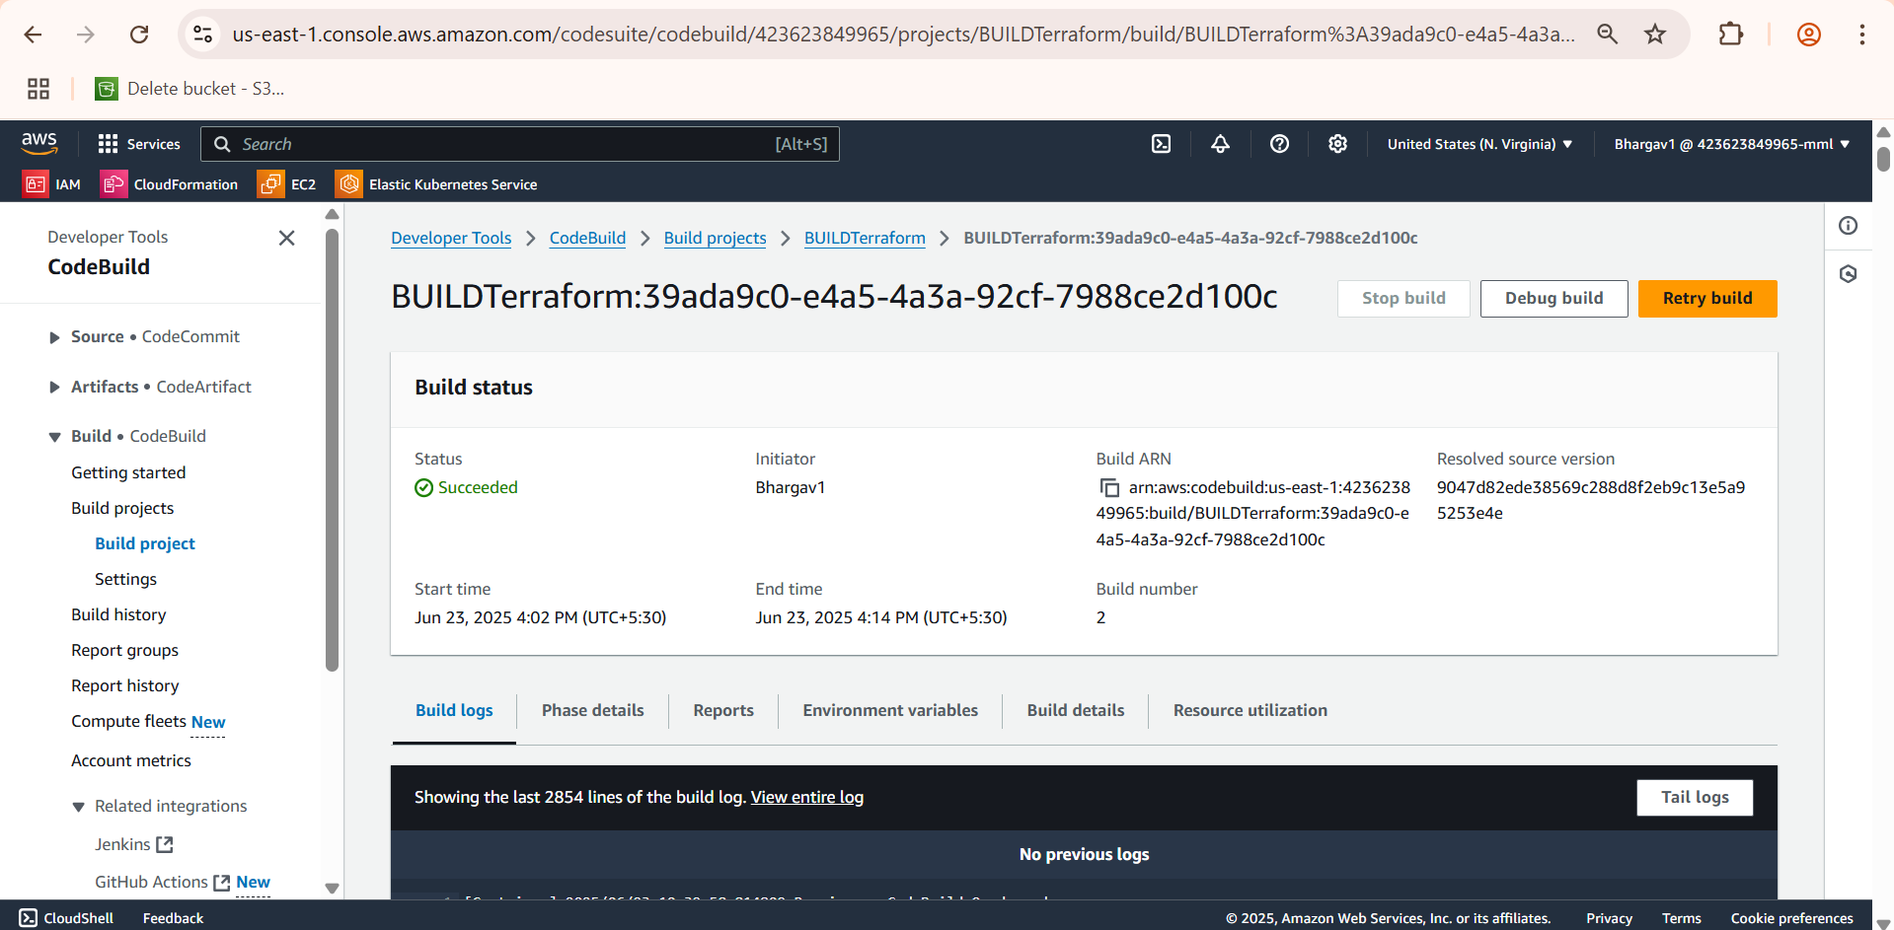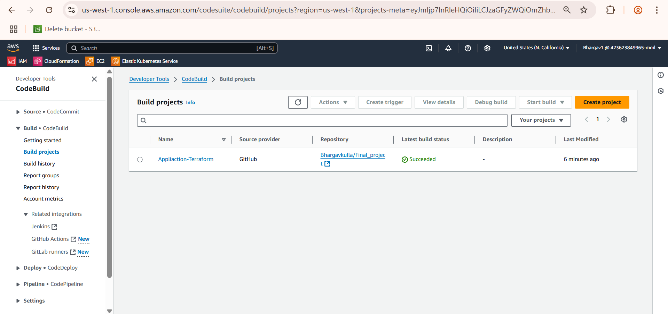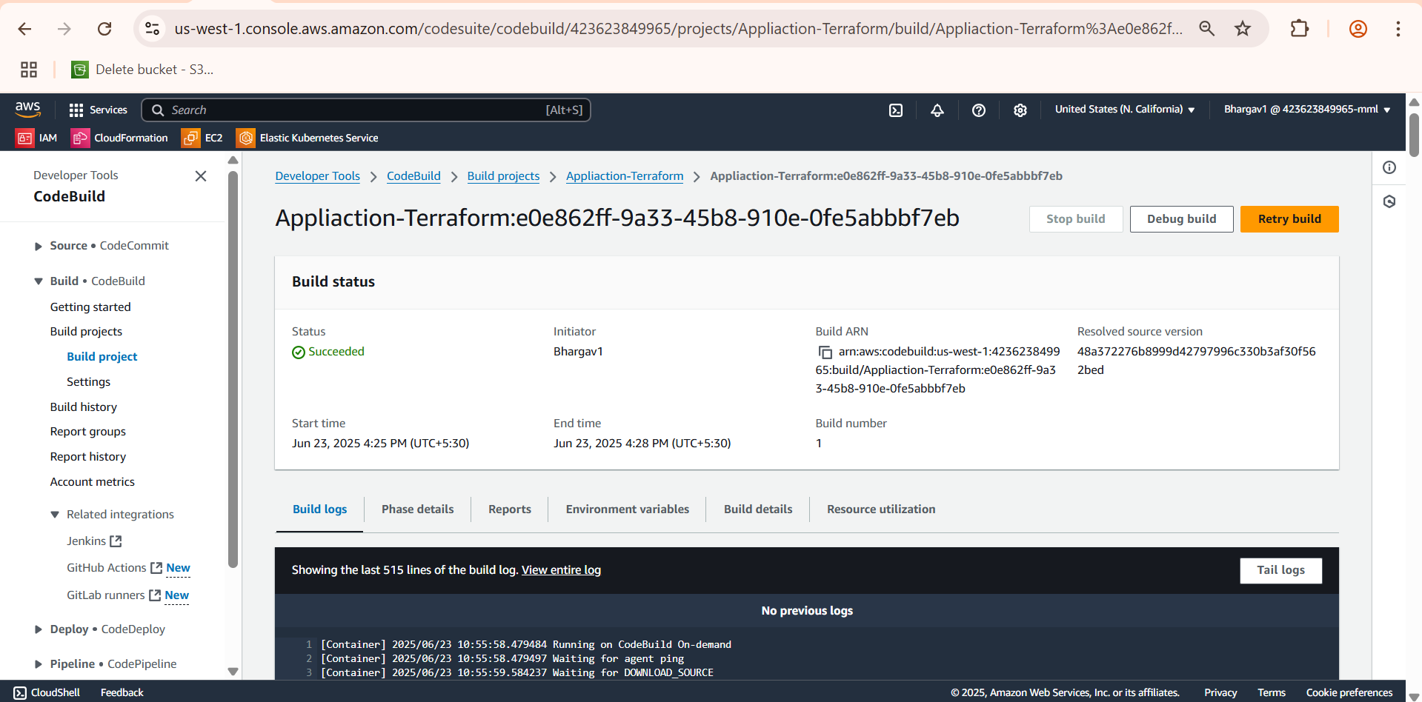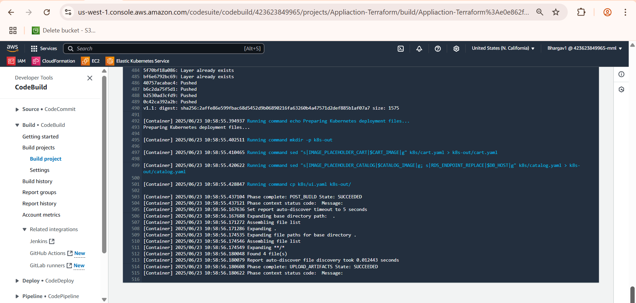 CodeBuild

